Jenkins-03

1. Create one Jenkins job using the below code and create three stages.
- stage1: Git clone to download the source code.
- stage2: Sonarqube Integration to check the quality of code.
- stage3: Slack Integration to send the alerts to slack.
Source Code: https://github.com/betawins/VProfile-1.git
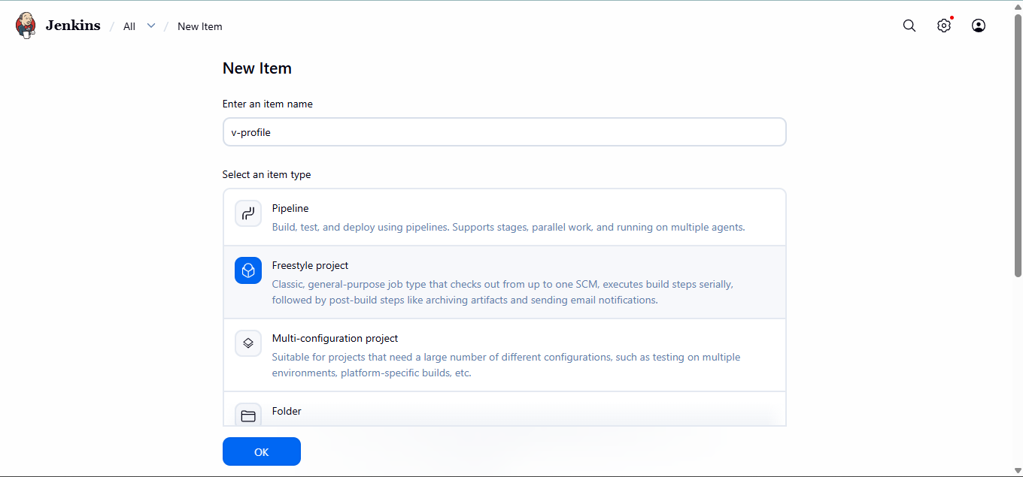

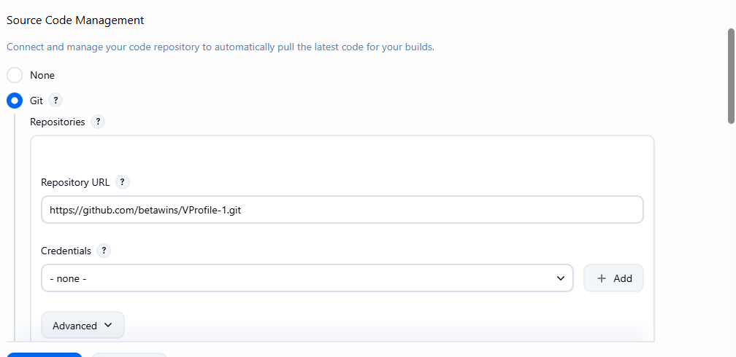

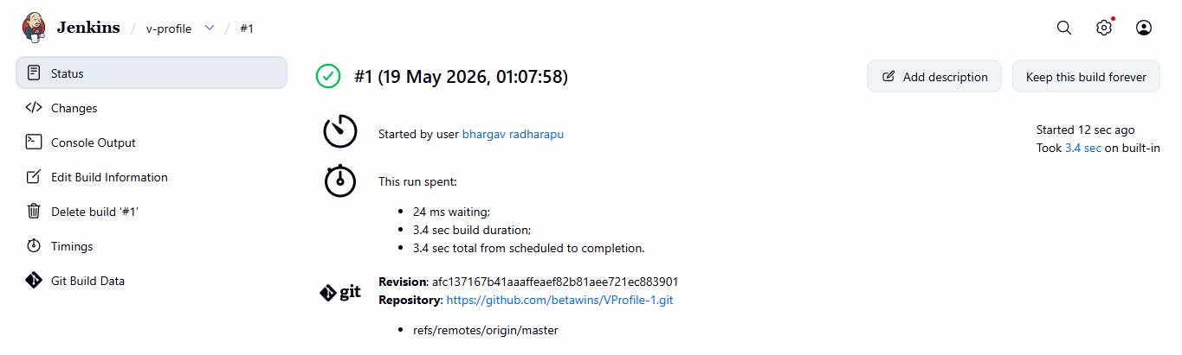

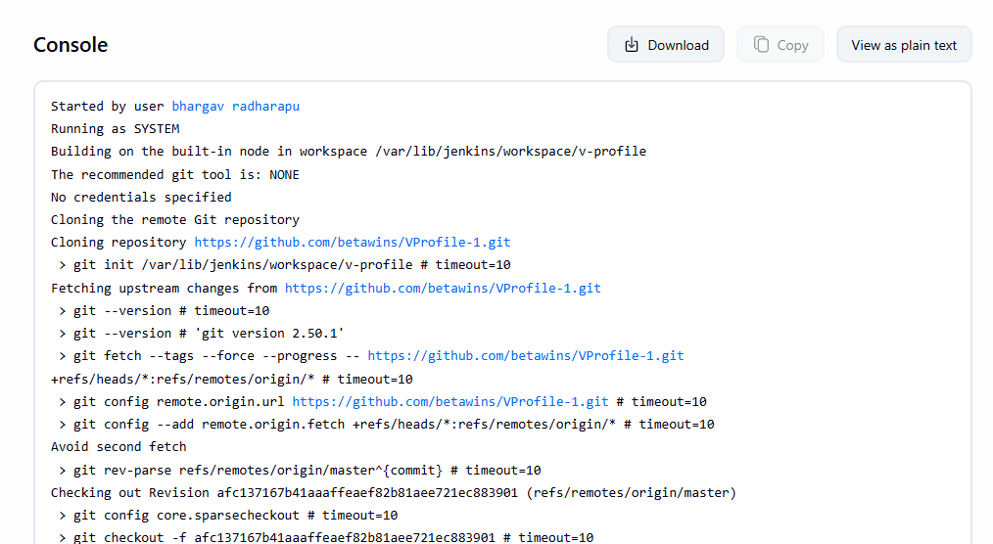

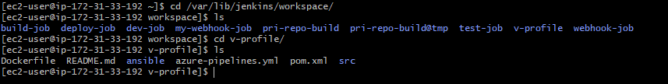

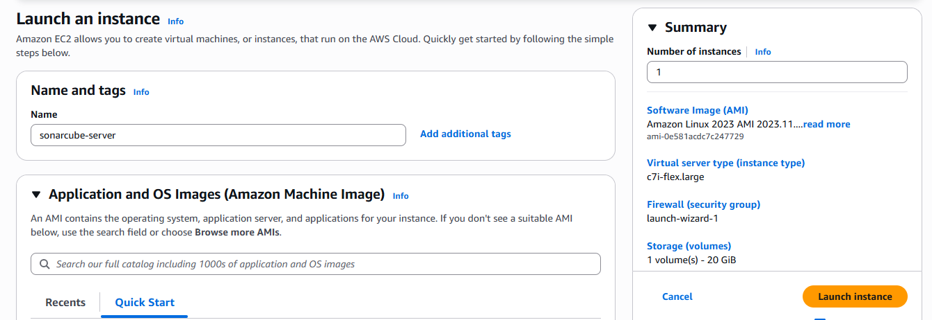

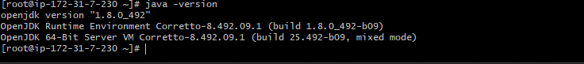
Install and Configure MySQL
- sudo wget https://dev.mysql.com/get/mysql57-community-release-el7-11.noarch.rpm
- sudo yum localinstall mysql57-community-release-el7-11.noarch.rpm
- rpm --import https://repo.mysql.com/RPM-GPG-KEY-mysql-2022
- sudo yum install mysql-community-server
- sudo systemctl start mysqld.service
- systemctl start mysqld
- systemctl enable mysqld
- To check mysql is running or not → netstat -na | grep 3306
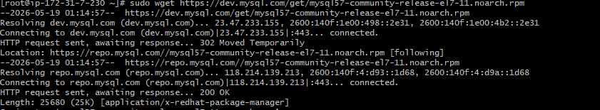
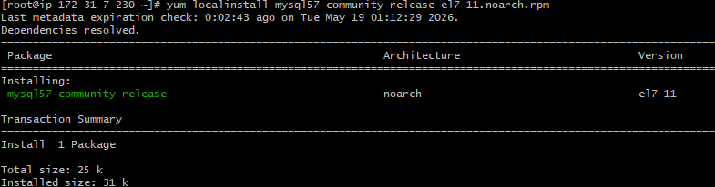
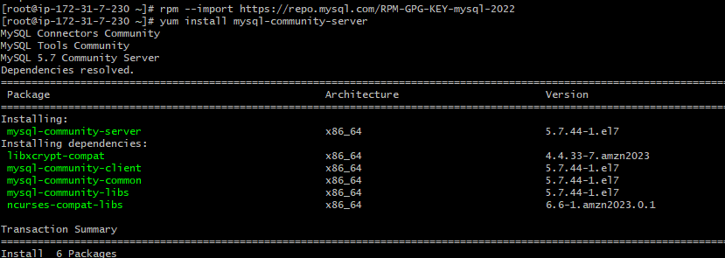
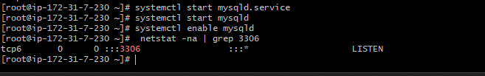
Configure the MySQL Root Password
• Retrieve the temporary root password from /var/log/mysqld.log
We can see default MySQL root password → grep 'temporary' /var/log/mysqld.log
First lets login to mysql using default password
mysql -u root -p
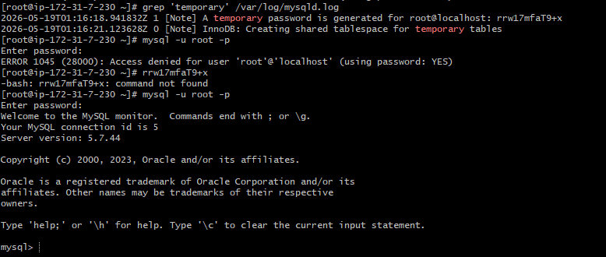
eplace the default password with a new and strong password
ALTER USER 'root'@'localhost' IDENTIFIED BY 'Admin@123';
flush privileges;
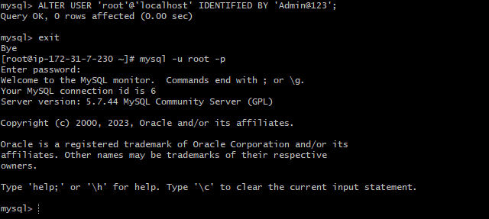

SonarQube Installation
To install sonarqube, goto → cd /opt/
To download : wget https://binaries.sonarsource.com/Distribution/sonarqube/sonarqube-6.6.zip
To Unzip : unzip sonarqube-6.6.zip
To Rename : mv /opt/sonarqube-6.6 /opt/sonar
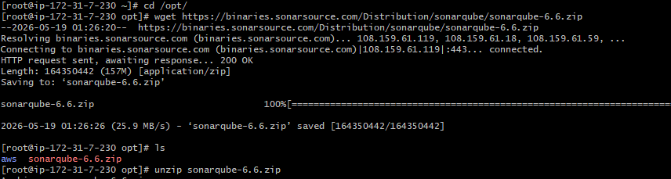
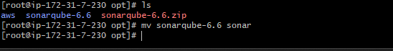
Created Databases and users, Gave the users the permissions and checkied if we did right
or
not.
Steps Involves and commands used
Create a new sonar database
CREATE DATABASE sonar CHARACTER SET utf8 COLLATE utf8_general_ci;
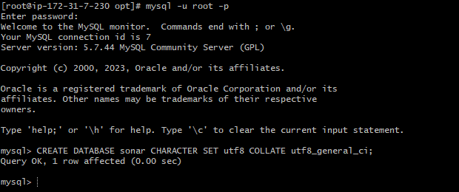
Create a local and a remote user
CREATE USER sonar@localhost IDENTIFIED BY 'Sonar@123';
CREATE USER sonar@'%' IDENTIFIED BY 'Sonar@123';
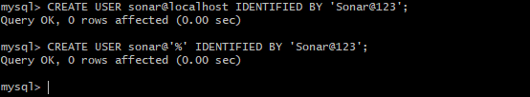
To check databases : show databases;
To check users : SELECT User FROM mysql.user;
FLUSH PRIVILEGES;
QUIT
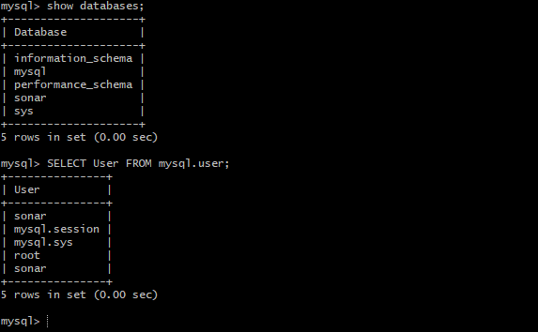
Lets enable SonarQube properties file to connect to the database
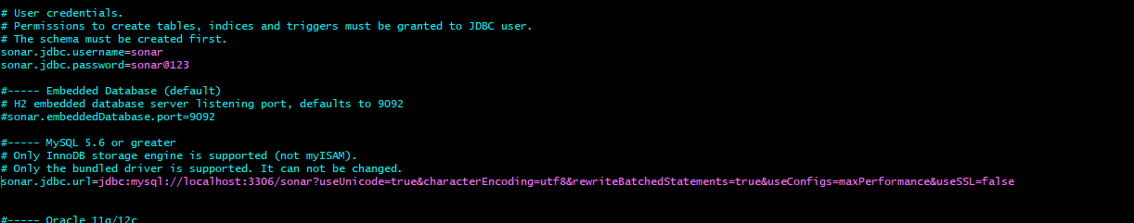
Create user
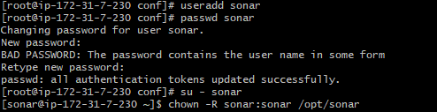
Switch to user
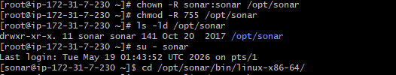
Started sonarqube
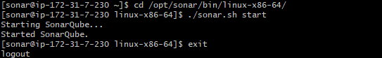
Successfully logged in sonarqube
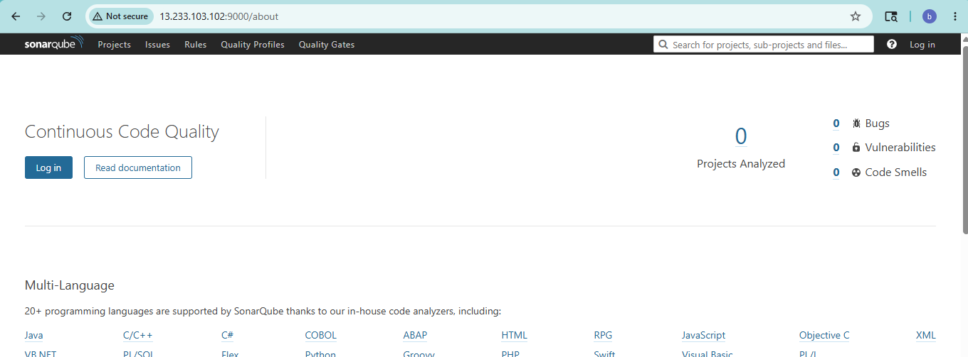
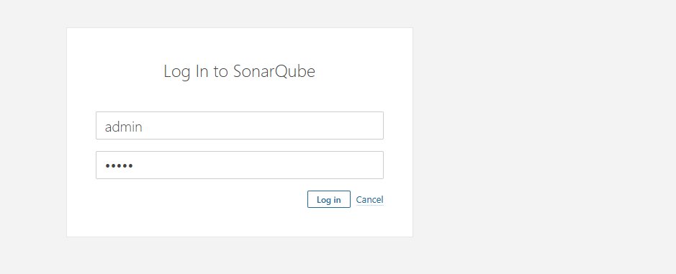
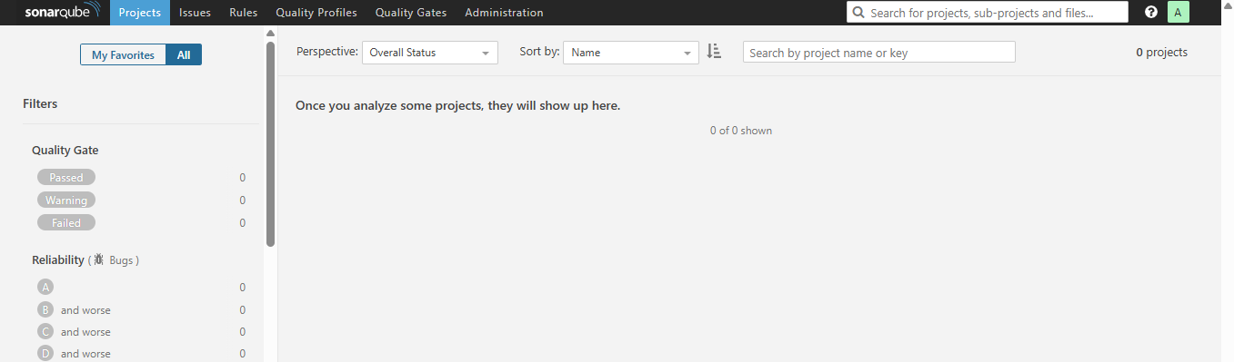
SonarQube Scanner on our Jenkins
Go to Manage JenkinsPluginsSonarQube scanner →click on Install
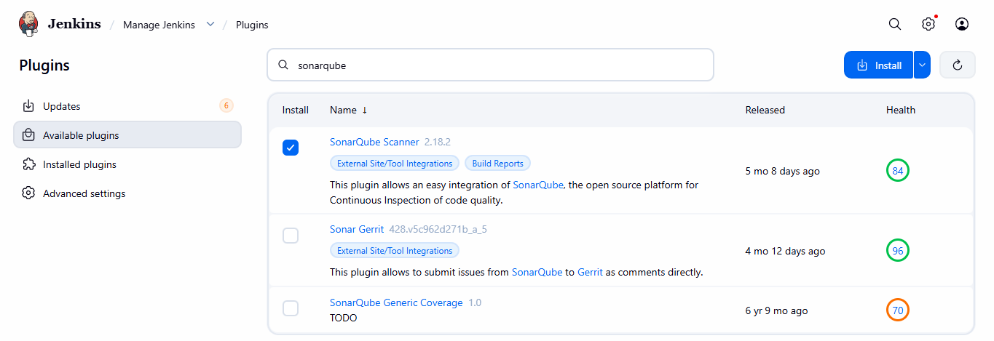
To create
Manage Jenkinsclick on systemSonarQube servergive NameServer URL Credentials
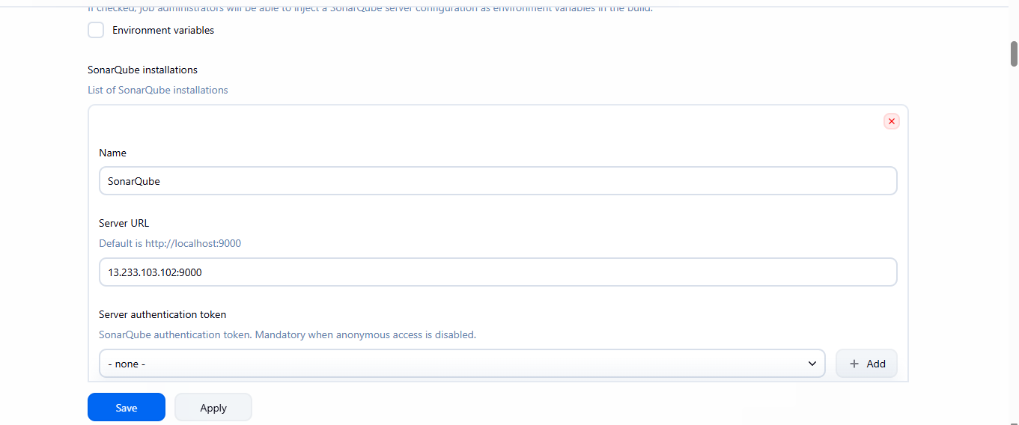
Generate an Authentication Token in SonarQube
Log into SonarQube → My Account → Security → Generate TokensCopy the generated token
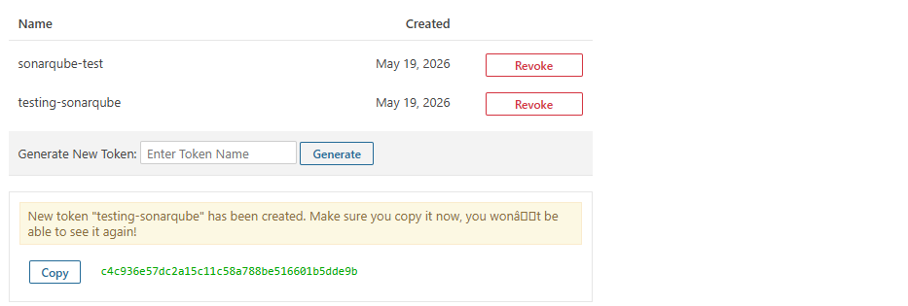
Add it to Jenkins credentials
Go to manage Jenkins click on credentials
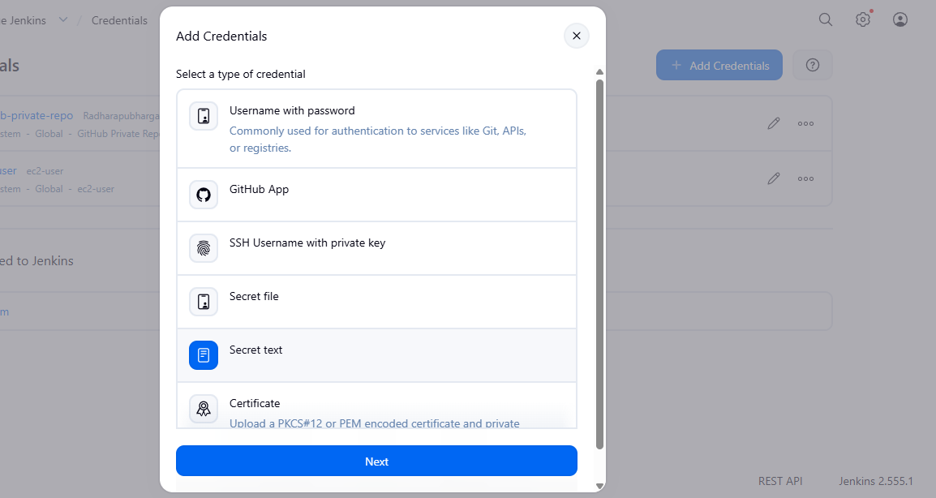
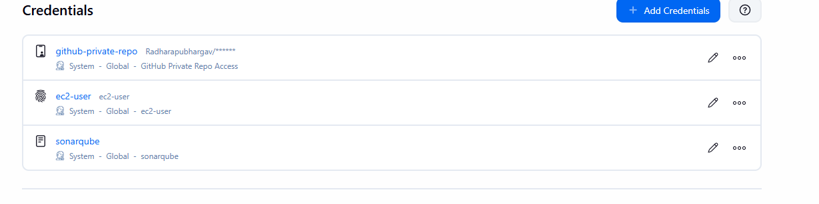
add the credential in the configurations
go to manage Jenkins click on system choose sonarqube server add credential to server
authentication token
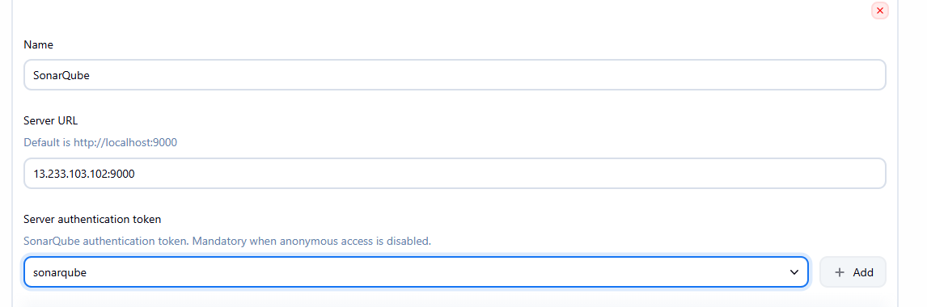
We need to install sonarqube-scanner in Jenkins server
To Download - wget https://binaries.sonarsource.com/Distribution/sonar-scanner-cli/sonar-scanner-cli-3.2.0.1227-linux.zip
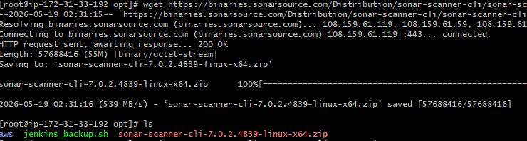
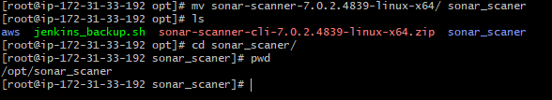
Add the above sonar-scanner path in the Jenkins
Go to manage Jenkins sonarQube Scanner Name Path →Save
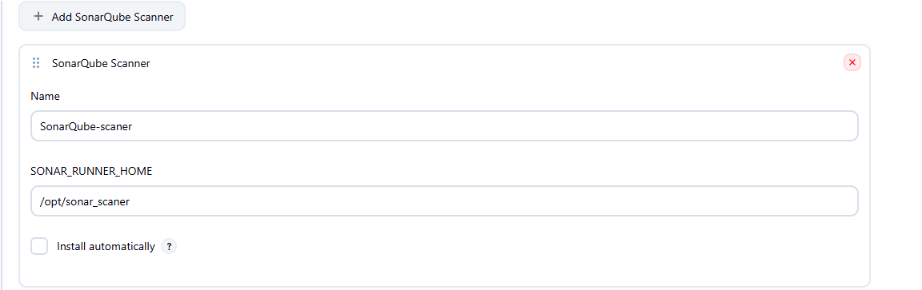

Next We need to give analysis properties of the code to run in the Job we created
Job Configure --?Build Steps Analysis Properties(we will get it from developers)
Save
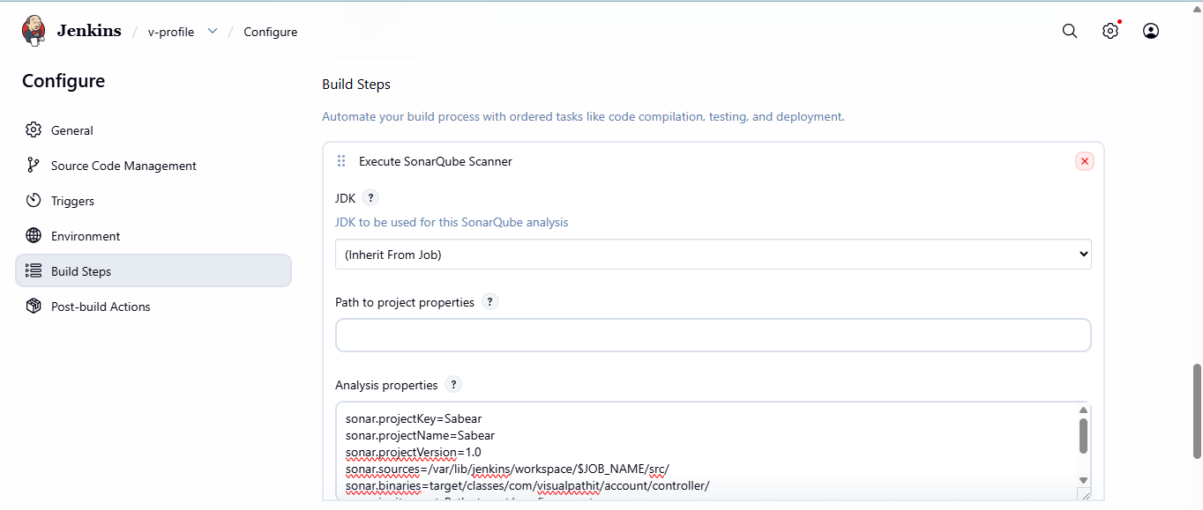
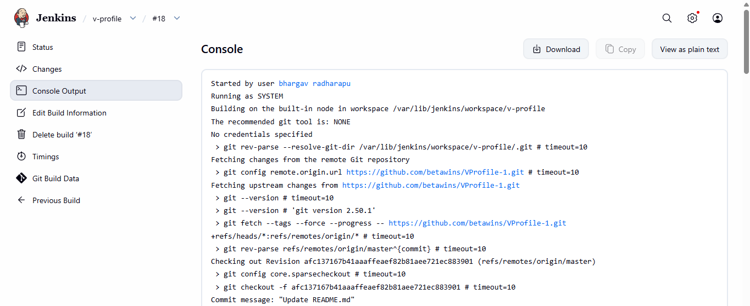
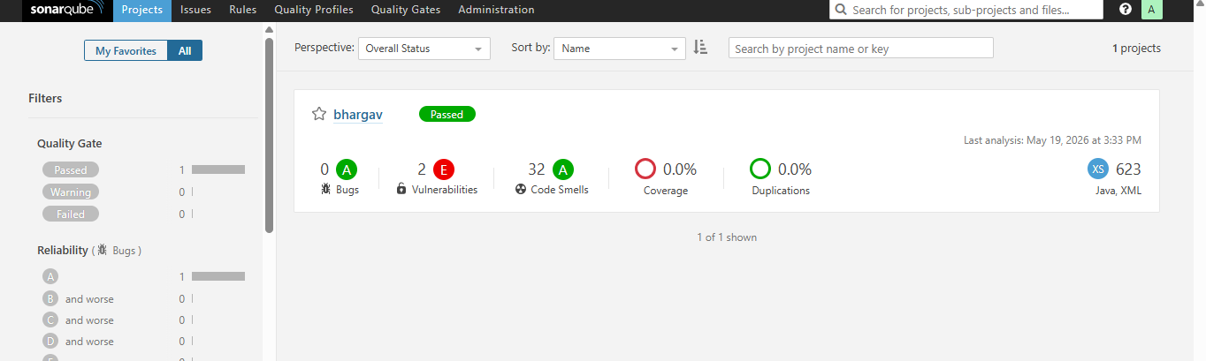
Stage 3 : Slack Integration to send the alerts to slack.
Go to manage Jenkins → plugins → available plugins → search for slack notification →
Install

Add pluginslack notifications
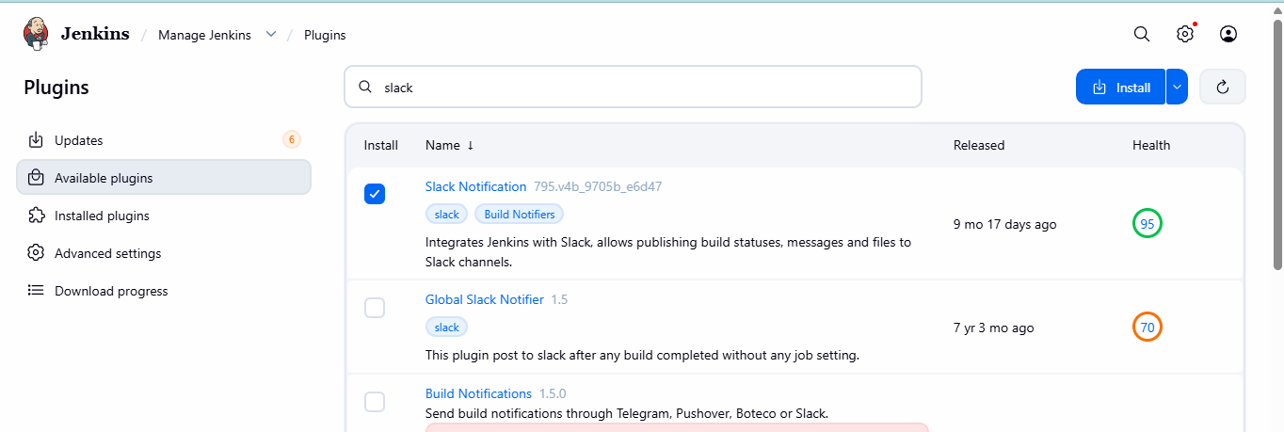
Create slack channel
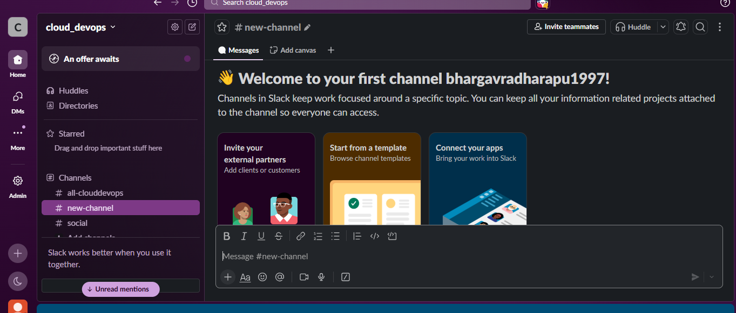
Add appsjenkins CIadd to slack
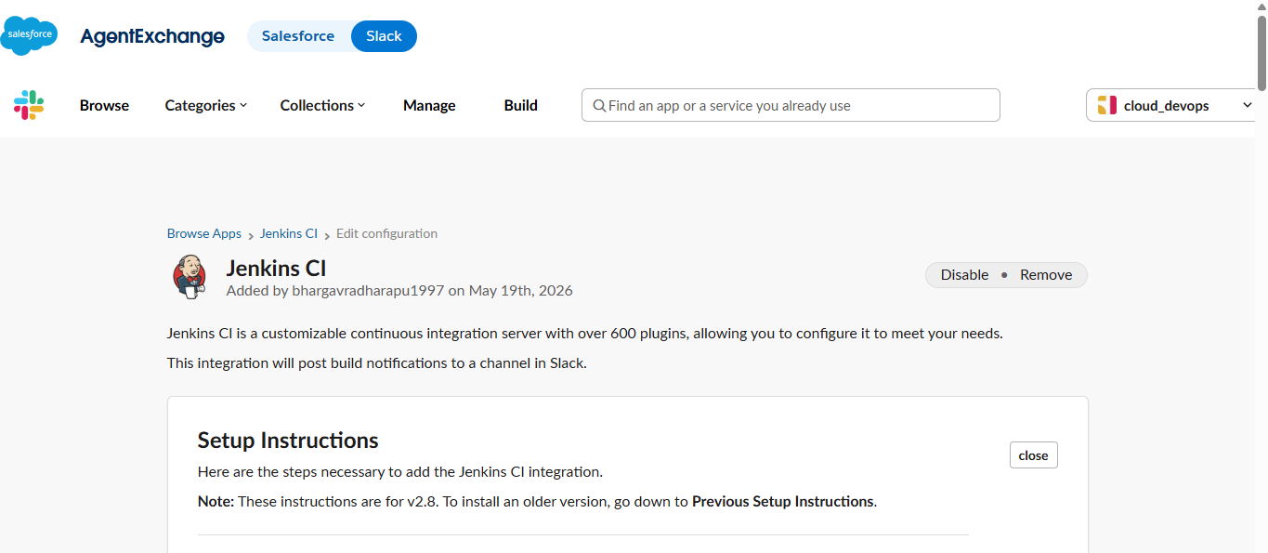

Copy token
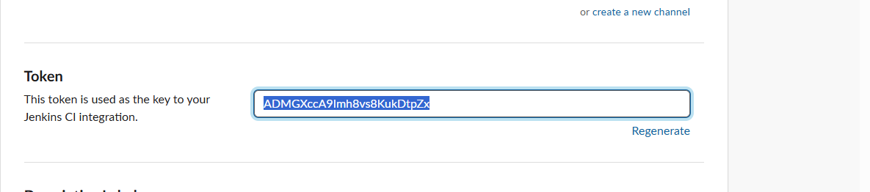
Copy member id
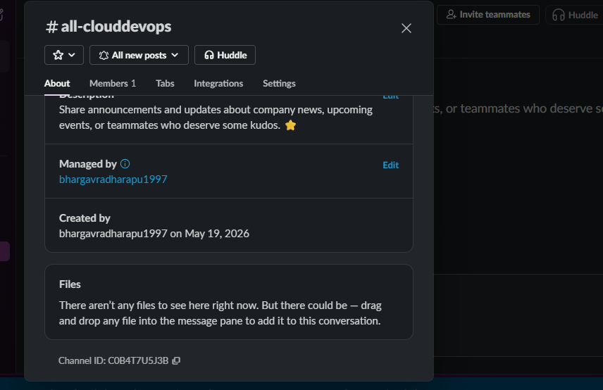
Configure slack
manage Jenkinssystemslack add work spacecredentialsmember idsave
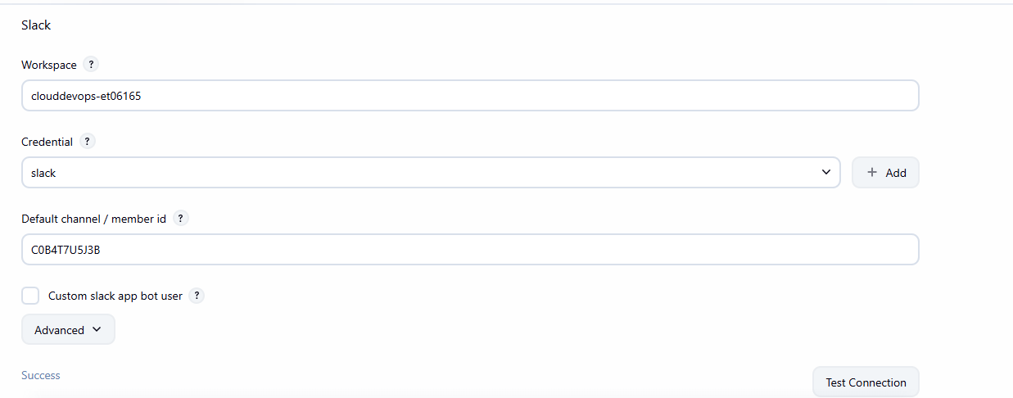

Add credentials
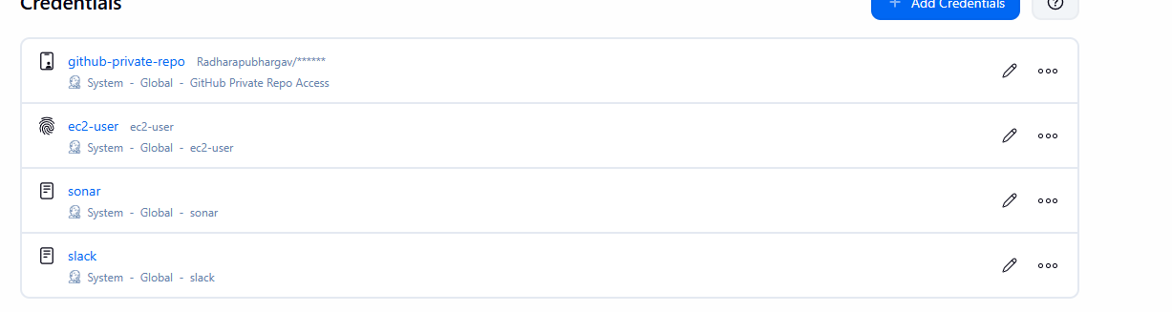
Here we can see connection is successful
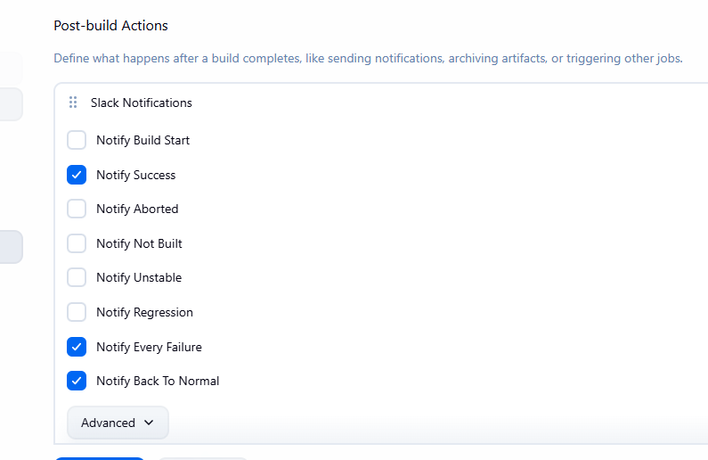
Also we are able to get the alerts in slack
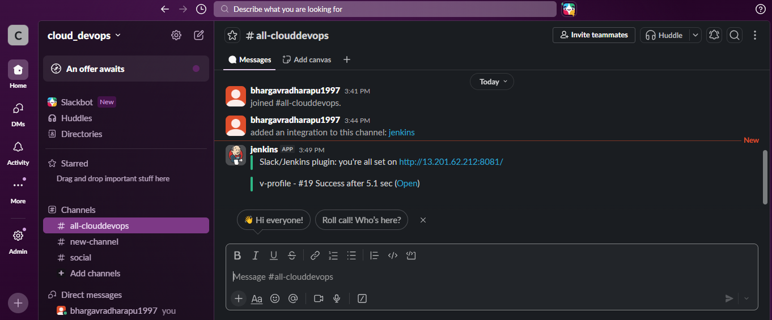

2. Create one Jenkins job using the below code and create three stages.
- stage1: Git clone to download the source code.
- stage2: Sonarqube Integration to check the quality of code.
- stage3: Slack Integration to send the alerts to slack.
Source Code: https://github.com/betawins/hiring-app.git
create a new build
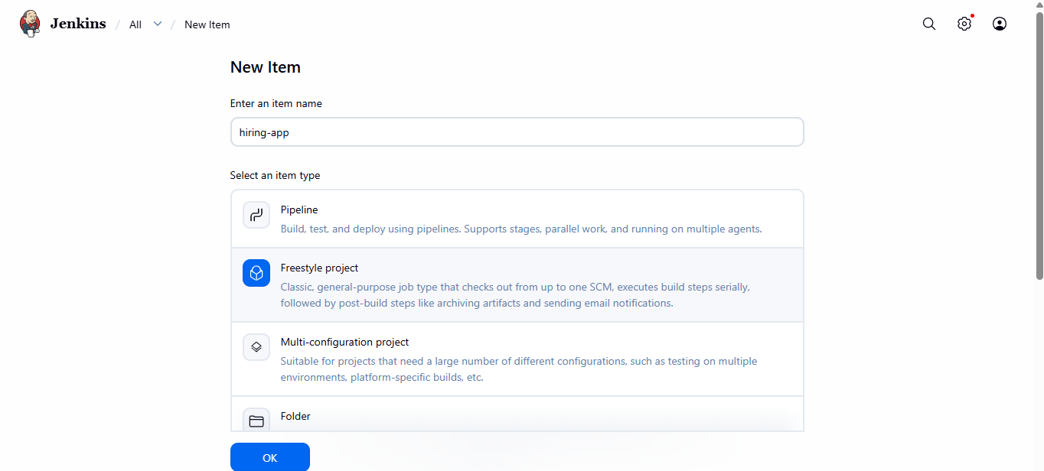
Choose git and provide url
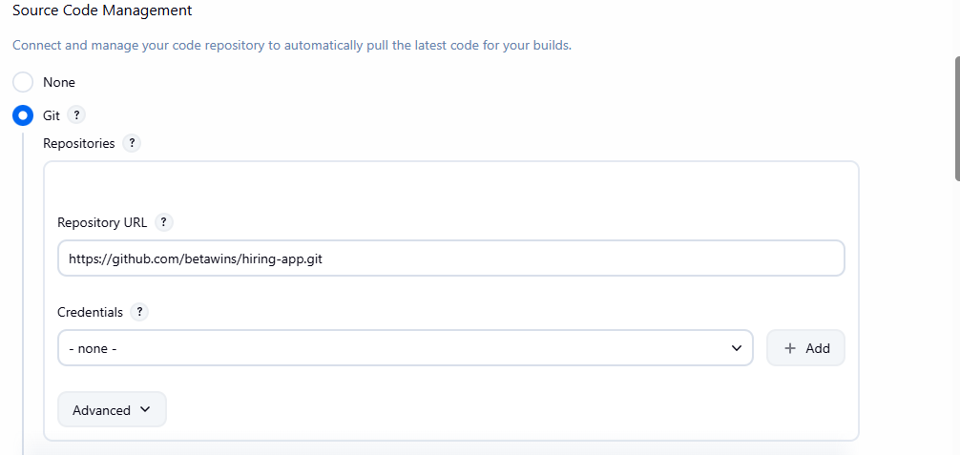

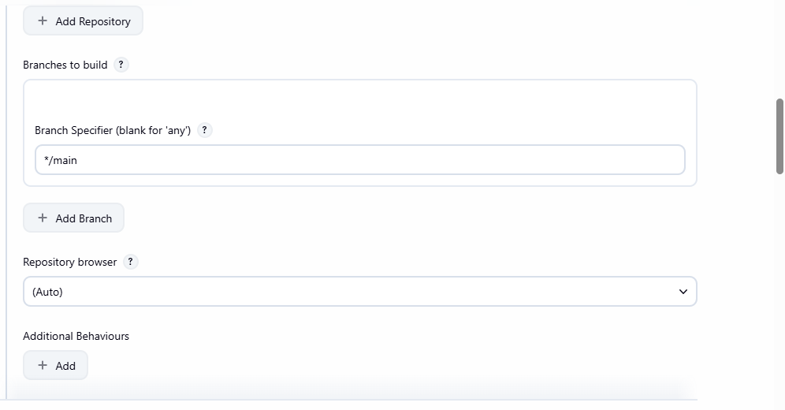
Click on add build step → choose sonarqube scanner
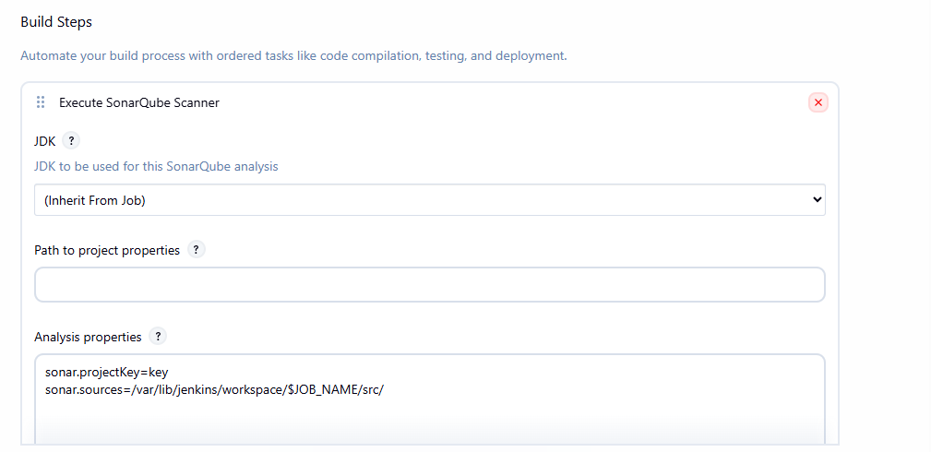

Go to post build actionschoose slack notification
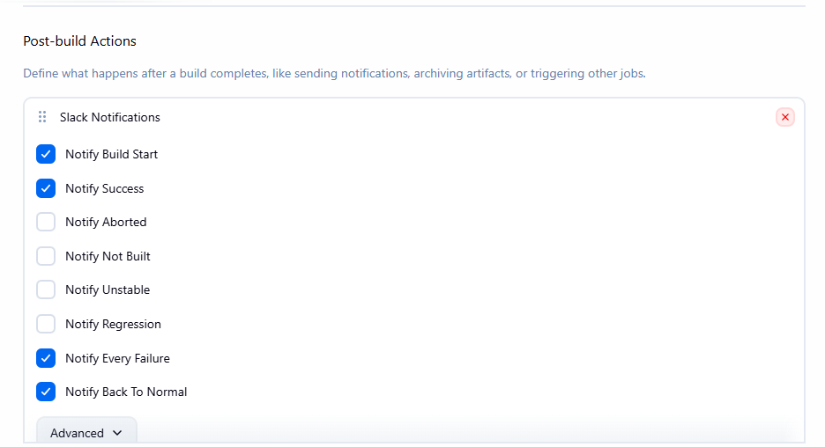
Provide workspace name channel idclick on test connection
We are able to get the alerts
